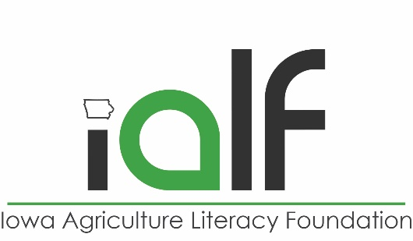

**Farmland Film Questions**

**Grades 9-12**

This discussion guide is intended for use in conjunction with the film FARMLAND. After watching FARMLAND, these questions should be answered soon after watching the movie and are intended to deepen students’ understanding of agriculture and the challenges that come along with it.

**Farmers:**

* Ryan raises hogs, corn, soybeans and small grains
* Brad is the cattle rancher from Texas
* Margaret is the vegetable farmer from Pennsylvania
* Sutton is the organic produce farmer from California
* David is the grain farmer from Nebraska
* Leighton is the chicken, cattle and hay farmer

1. The farmers in the movie discuss the image of the farmer, and how it can range from a romanticized *American Gothic* type image to that of a corporate CEO. Based on what you’ve heard in the movie, where do you think the average farmer lies on this spectrum, and what do you think the cause of this disparity is?
2. From factors out of the farmers control to the capital required to farm, farmers have to manage risk successfully to be a lucrative business. How can farmers manage this risk?
3. Several of the farmers talk about their farms as businesses from where their living is derived despite them still being family farms. Describe some of the struggles of farming as a business. Do you see differences between farm businesses and other business you have come in contact with?
4. Compare and contrast organic production, natural production, and conventional production.
5. GMOs (genetically modified organisms) are a seed technology that many farmers choose to use. Based on the thoughts of the farmers and any background knowledge you have, compare and contrast possible advantages and disadvantages of genetic engineering.
6. Leighton talks about marketing a hormone-free chicken. Is it fair to market food based on consumers’ lack of knowledge? Are there other examples of similar marketing tactics?
7. The farmers all talk about the importance of water in their farming operations and a fear of running out of water. How is water used in agriculture?
8. Community Supported Agriculture is a program that allows people to sign up for a season’s worth of locally grown produce and pick it up from a farm. Margaret participates in this program. How can this benefit both the producer and consumer? How does this compare to traditional marketing of commodities?
9. Name some of the technology featured in the movie and discuss potential benefits and risks of each technology.
10. The farmers in the movie talk about how agriculture has changed over the years. What are some of these significant changes and what are their implications?
11. How do you create a sustainable farm?
12. What are some of the differences between small scale production and large scale production?
13. What are some of the problems involved with transferring a farm from one generation to the next?
14. If you had the opportunity to meet one of the farmers in the documentary, which one would you want to meet and why?
15. Did this movie change your perceptions of agriculture? Were you surprised about anything the farmers in the movie talked about?
16. Are there any situations or people in this documentary you can relate to?